**Project Title1:**  
**Wanderlust Tales – Travel Blog Template**

**Submitted By:**  
Jessica John Osta

**Roll Number:**  
2460376

**College Email ID:**  
jessica.john@btech.christuniversity.in

**Project Title 2 :**  
Harry Potter Movie Series Info Page

**Submitted By:**  
Anindita Saha

**Roll Number:**  
2460328

**College Email ID:**  
anindita.saha@btech.christuniversity.in

**Date of Submission:**  
13 August 2025

**Course:**  
UI/UX Design Fundamentals

**Instructor Name:**  
Nagaveena

**Institution:**  
CHRIST (Deemed to be University)

**Date of Submission:**  
13 August 2025

**2. Abstract**

This project, *Wanderlust Tales – Travel Blog Template*, is a responsive and visually appealing travel blog webpage created using only HTML5 and CSS3. It is designed to present travel stories, photographs, and destination highlights in an engaging format. The key goal is to deliver a clean, user-friendly interface with a modern layout that adapts seamlessly across desktop, tablet, and mobile devices. Core features include a video background in the hero section, a grid-based recent posts layout, a sidebar with bio and categories, an Instagram gallery, and a newsletter subscription form. The project focuses solely on front-end design, implementing semantic HTML structure and CSS styling without the use of external libraries or JavaScript. The final outcome is a functional, responsive travel blog template that is useful for personal portfolios, travel bloggers, or content creators.

## ****3.Objectives****

* Design a user-friendly interface following modern UI/UX principles.
* Develop a fully responsive layout using only HTML and CSS.
* Implement structured HTML5 semantic elements for better accessibility and SEO.
* Apply CSS styling for consistent branding, layout, and responsiveness.
* Ensure readability and accessibility across various screen sizes and devices.

**4. Scope of the Project**

* Focused entirely on **front-end design** using HTML5 and CSS3.
* No JavaScript or server-side functionality is included.
* Optimized for **desktop, tablet, and mobile viewports**.
* Uses **open-source tools** and pure code without external frameworks or libraries.
* Includes sections such as video hero banner, recent posts grid, bio & categories sidebar, Instagram gallery, newsletter subscription, and back-to-top button.

**5. Tools & Technologies Use**

| **Tool/Technology** | **Purpose** |
| --- | --- |
| HTML5 | Markup and content structure |
| CSS3 | Styling and layout management |
| VS Code | Code editor |
| Chrome DevTools | Testing and debugging |

## ****6. HTML Structure Overview****

* Used semantic tags: <header>, <nav>, <main>, <section>, <footer>.
* Structured into reusable sections: Featured post, Recent posts, Sidebar, Footer.
* Navigation menu created using <a> links for smooth navigation

## ****7. CSS Styling Strategy****

* Used external CSS file (blog.css).
* Organized with comments and sections.
* **Techniques used:**
  + Flexbox and Grid for layout.
  + Media Queries for responsiveness.
  + CSS Variables for theme customization.
  + Hover effects and transitions.
  + Mobile-first design approach.

## ****8. Key Features****

| **Feature** | **Description** |
| --- | --- |
| Responsive Design | Adapts seamlessly to all screen sizes |
| Video Background | Engaging hero section with autoplay video |
| Recent Posts Grid | Grid layout with hover effects |
| Sidebar Bio & Categories | Personal intro and organized categories |
| Instagram Gallery | Display of featured travel photos |
| Newsletter Form | Email subscription form (non-functional) |
| Back to Top Button | Smooth scroll functionality |

## ****9. Challenges Faced & Solutions****

| **Challenge** | **Solution** |
| --- | --- |
| Overlapping elements on small screens | Used media queries to stack elements |
| Difficulty aligning items using float | Shifted to Flexbox and Grid |
| Typography scaling issue | Used relative units (em/rem) instead of px |

## ****10. Outcome****

* Achieved a clean, consistent, and visually engaging travel blog template.
* All components function as intended using HTML and CSS only.
* Gained deeper understanding of responsive design, semantic structure, and UI hierarchy.

## ****11. Future Enhancements****

* Add JavaScript for interactivity (form validation, dynamic content).
* Integrate animations or transitions.
* Backend integration for form submission.
* Add a theme toggler (light/dark mode).

**12. Sample Code**

CSS for the Responsive Grid Layout

The post-grid class is a great example of the responsive design. On smaller screens, the layout is a single column, but a media query changes it to a three-column grid on screens wider than 768px.

CSS

.post-grid {

display: grid;

grid-template-columns: 1fr;

gap: 1em;

}

@media(min-width: 768px) {

.post-grid {

grid-template-columns: repeat(3, 1fr);

}

}

**HTML for the Featured Video Section**

The featured-post section uses a video tag with autoplay, muted, and loop attributes to create a seamless, non-intrusive background video effect.

HTML

<section class="featured-post">

<video autoplay muted loop playsinline class="bg-video">

<source src="images/posts/featured-video.mp4" type="video/mp4">

Your browser does not support the video tag.

</video>

<div class="featured-content">

<h1>Exploring the Hidden Beaches of Bali</h1>

<p>Join me as I uncover Bali’s serene and untouched beaches, away from the bustling tourist spots...</p>

<a href="#" class="read-more">Read More</a>

</div>

</section>

**13. Screenshots of the webpages**

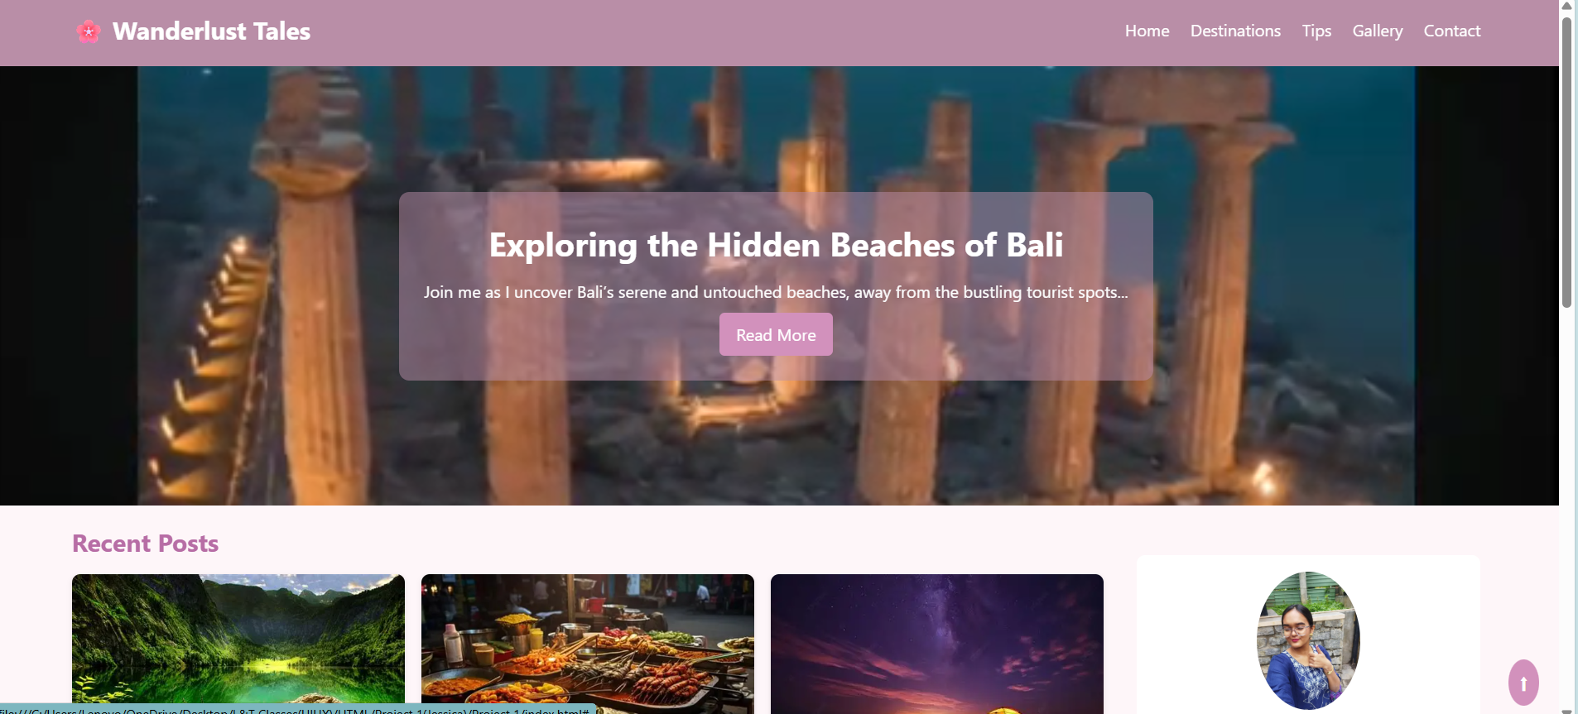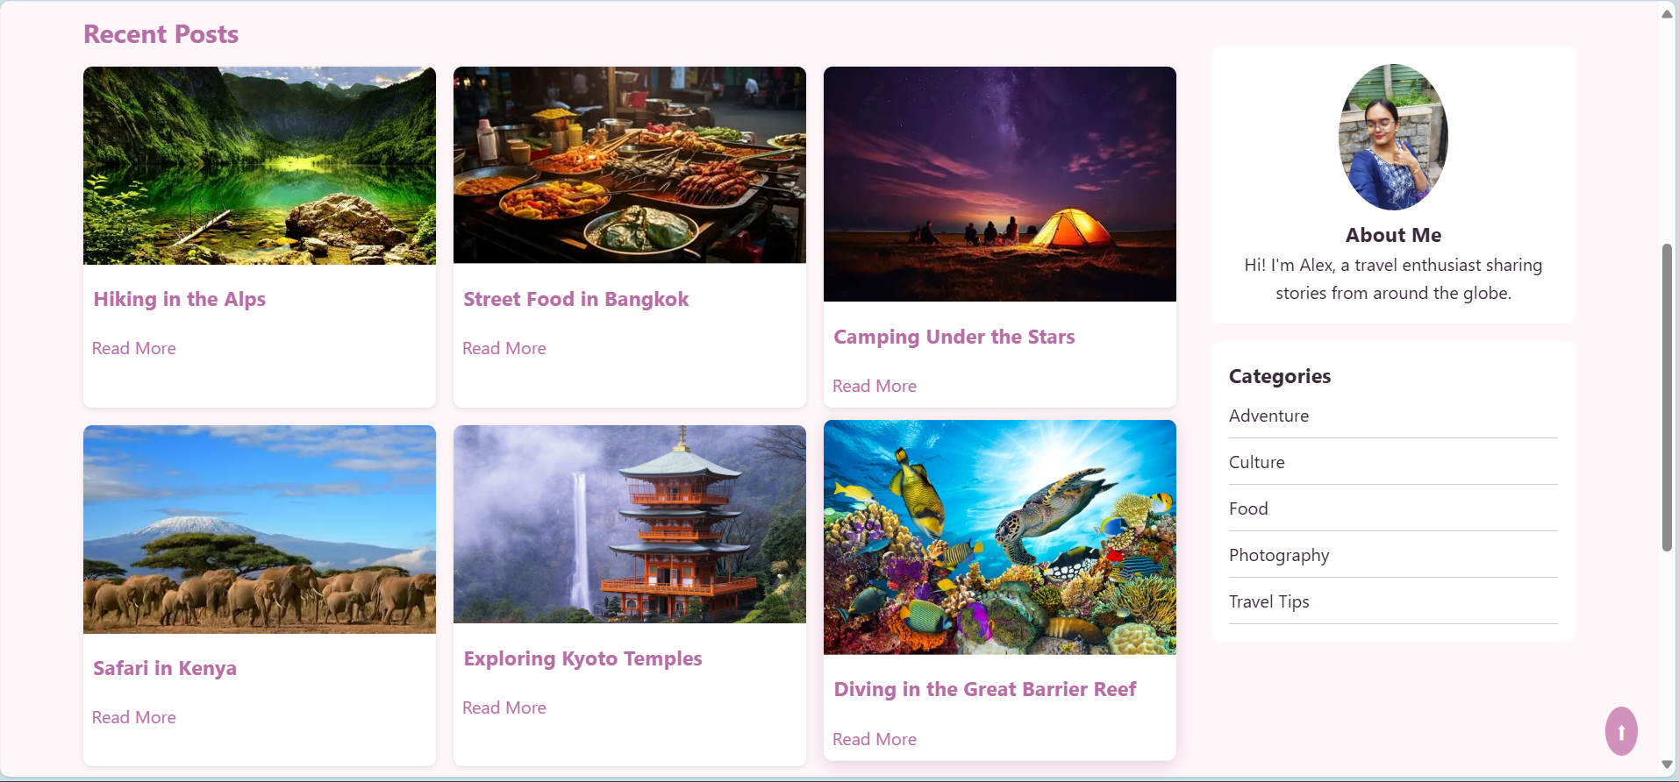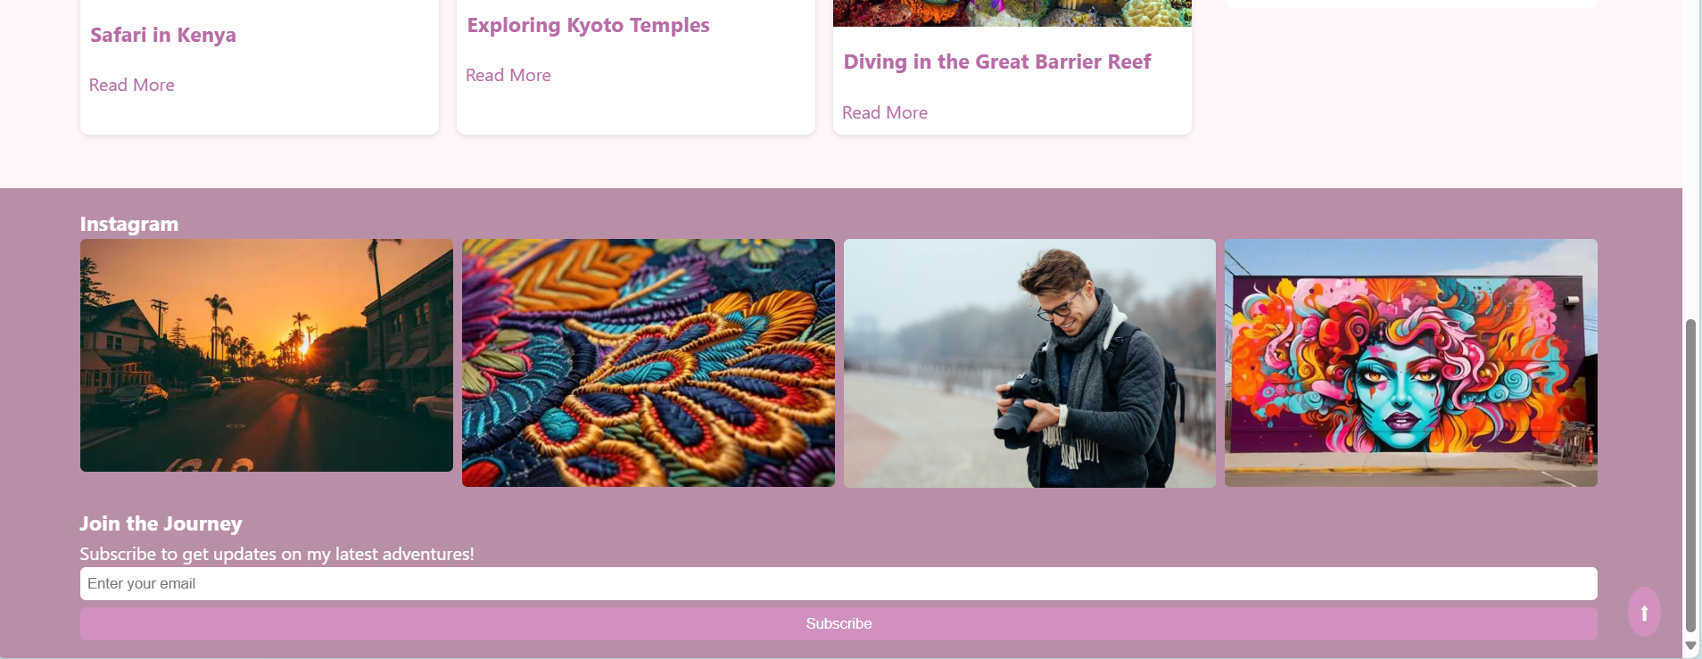

## ****14. Conclusion****

This project showcases how **HTML5** and **CSS3** can be leveraged to build a professional, responsive travel blog interface **without relying on external frameworks**. Through this experience, I:

* Strengthened my skills in **front-end development**, including layout design, media queries, and cross-device responsiveness.
* Applied **semantic HTML** principles to ensure accessibility, SEO optimization, and clean document structure.
* Focused on **user-centered aesthetics**, balancing visual appeal with intuitive navigation.Developed strategies to **troubleshoot design challenges**, refine UI components, and maintain scalable, well-organized code.

This hands-on project deepened my understanding of modern web standards and reinforced my ability to create elegant, functional interfaces from scratch.

## ****15. References**** • L&T LMS : https://learn.lntedutech.com/Landing/MyCourse